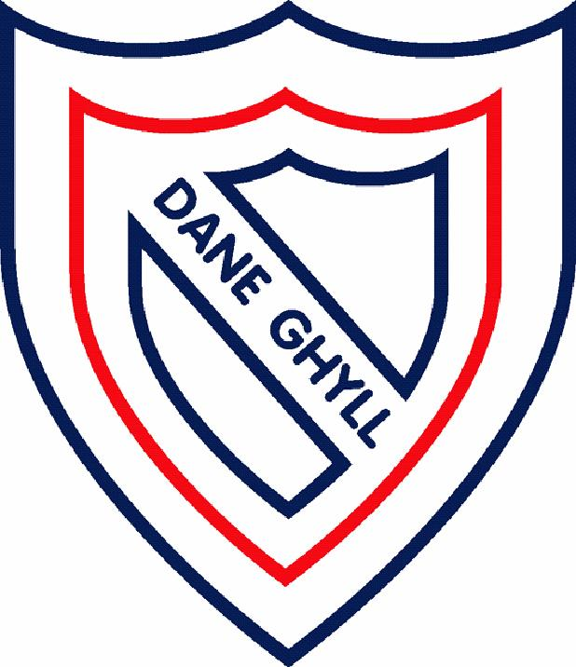
Key Skills
Painting and use of materials
Artistic Expression
Effective art techniques
Knowledge of Artists
Art

 | Reception | Year 1 | Year 2 | Year 3 | Year 4 | Year 5 | Year 6
Materials | Use materials creatively to design and make products.  Use drawing, painting and sculpture with different materials. | Explore and understand the impact of materials including hard and soft pencils, wet and dry paper, paint and ink.  Use a range of textile equipment including beads and fabric/thread for sewing. | Introduce chalk and pastels alongside other drawing materials to broaden range of drawing techniques.  Simple dyeing techniques including tie dying, and printing.  Work with a range of paints including powder, ready mix and block. | Introduce sculpture materials including clay and tools to create decorations on clay including engravers and embossing tools.  Different pencils for different purpose and effects.  Combine materials and give reasons for choices. | Begin to experiment with different tools for line drawing.  Create and make designs with applique onto fabric.  Decorate fabric using different materials to finish.  Introduce tints and stains to paint work.  Use more hardwearing materials (card, cardboard, wood) for creating 3D structures. | Experiment with working on different surfaces.  Different textures (laminating, modroc, collage.)  Natural materials to create sculptures. | Explore materials to create sculptures (mod roc, clay, natural materials, household object, chicken wire.)  Different textures and consistencies of paint.
Expression and Imagination | Develop and share their own imagination and experiences through art. | Create Art from imagination.  Create a piece of Art that is responding to an experience. | Respond to a range of stimuli.  Begin to give reasons for choice of materials and colours. | Respond to the work of others and say how it makes them feel or think and give reasons as to why. | Talk about their intention and how they wanted their audience to feel or think. | Use Art to express an emotion. Why have they chosen the materials and techniques that they have? | Use Art to express an abstract concept e.g war, love, creation.
Techniques | Develop and use texture, colour, line, pattern, shape, form and space. | Explore line and mark making in different ways.  Work with a variety of different brushes.  Threading and using a needle to create a stitch.  Colour mixing.  Use a range of tools (sponges, fabric) to begin to experiment with texture. | Practise a variety of methods for dying material.  Explore shading with a pencil.  Creating light and dark colours by tinting.  Explore pattern through printing and stamping.  Create work using natural materials to develop skills on texture. | Manipulating clay using fingers and tools.  Decoration techniques such as embossing, engraving and imprinting.  Variety of stitching techniques (running, stabbing)  Draw outlines with reference to size and shape. | Mixing tertiary colours (browns, neutrals, flesh.)  Build up painting techniques (resist work, layering, and scraping.)  Use pencils to create tone and shade and intricate marks when drawing.  Use joining techniques such as slotting, tying, pinning and sewing when creating 3D structures. | Use drawing techniques to introduce perspective.  (Drawing from above and below, near/far.)  Begin to experiment with the techniques of different artists.  Practice skills to create different surfaces.  Develop sculpture techniques by manipulating natural materials to create a structure. | Use viewfinders and perspective techniques in composition.  Apply paint to show textures.  ‘Limited palette’ work. Working with one colour and developing work using tints and shades.  Construct scale models using joining and drawing techniques.  Combine techniques and give reasons for choices.
Artists | Look at a range of work by different artists.  Say whether they like or dislike it begin to give reasons why. | Explore a range of work by other artists, craft makers and designers.  Be able to give their opinion and say why they like/dislike the work of other artists. | Continue to explore and be exposed to work by other artists and designers.  Be able to describe the similarities and differences between pieces of work by other artists.  Work alongside an artist in order to make links to their own work. | Begin to research great artists and designers through time.  Begin to include elements of other artists work in their own.  Be able to appraise the work of other artists and designers and say how their work links to their own. | Begin to develop an understanding of the work of an architect to tie in with work on 3D structures and sculptures.  Have an in-depth knowledge of one famous artist in time and be able to link their own work to them.  Be exposed to great pieces of art and craftsmanship through visits, visitors and experiences. | Use the work of a famous artist as a stimulus for their own work.  Use other artists work as a basis for critique.  Research and develop the techniques of other artists to use in own work.  Be introduced to the work of great designers through history. | Have an in-depth knowledge of the work of an architect and choose a style to emulate in constructing a scale model.  Be able to identify and appraise the work of designers through history.

